Project Design Phase-II
Technology Stack (Architecture & Stack)
Date | 13 September2026
Team ID | ________________
Project Name | Automated Network Request Management in ServiceNow
Maximum Marks | 4 Marks

Technical Architecture
ServiceNow Service Portal and Service Catalog provide the requester interface. Catalog variables and form logic capture validated data. Flow Designer manages approvals, fulfilment tasks and notifications. ServiceNow records provide request, task, approval and configuration data.
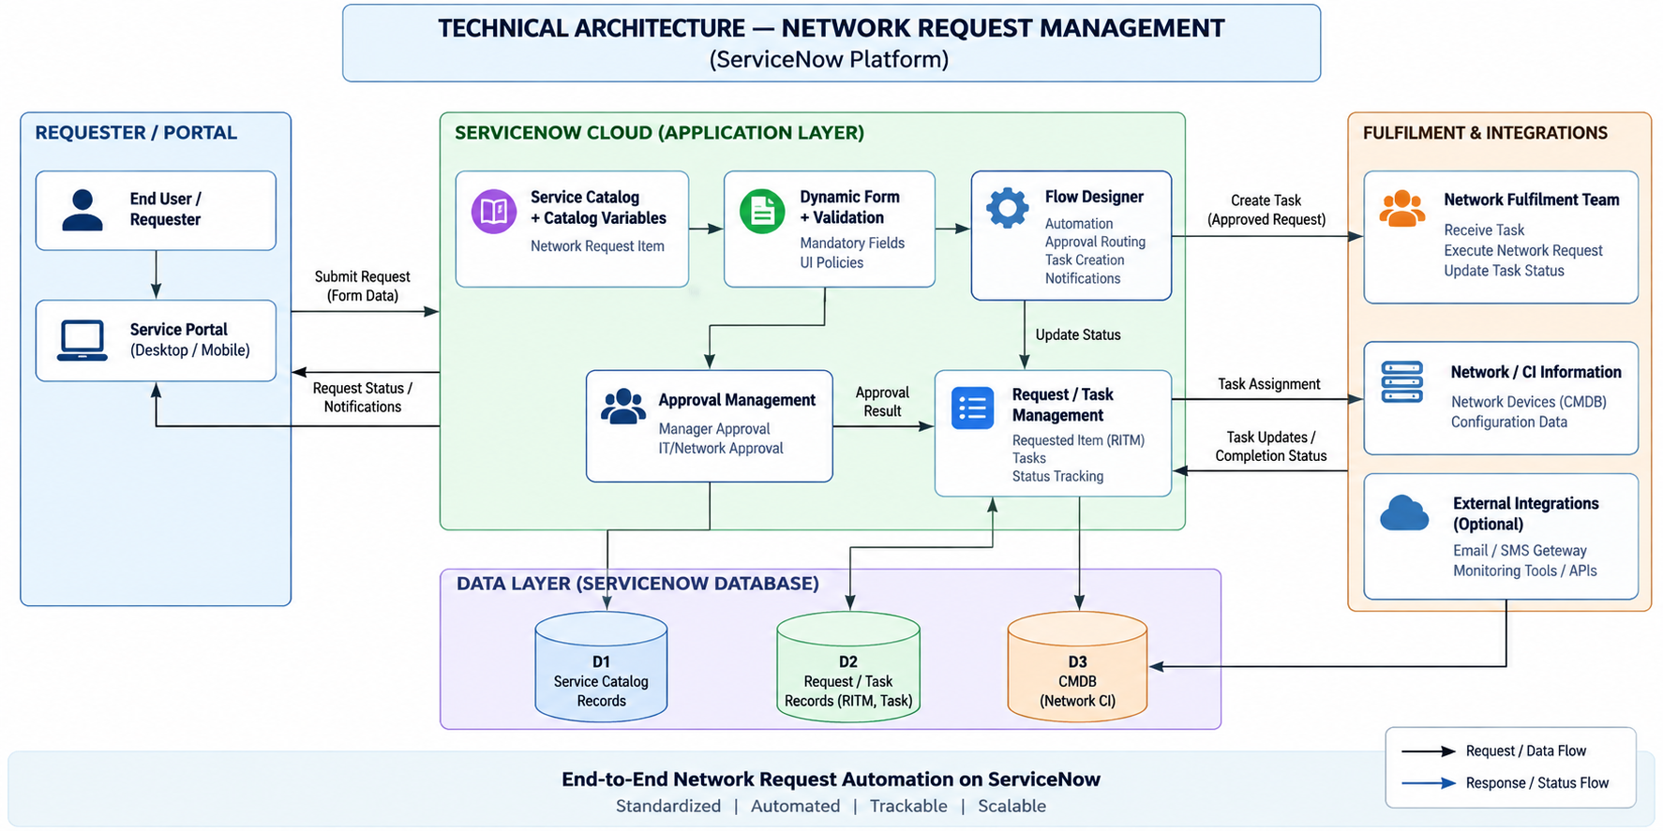
Table-1: Components & Technologies
S.No | Component | Technology / Configuration
1 | User Interface | ServiceNow Service Portal / Service Catalog UI
2 | Application Logic-1 | Catalog Items, Variables and UI Policies
3 | Application Logic-2 | ServiceNow Flow Designer
4 | Application Logic-3 | Approvals and Notifications
5 | Database | ServiceNow platform tables / custom network request table
6 | Cloud Database | ServiceNow platform data storage
7 | File Storage | ServiceNow attachment storage, if required
8 | External API-1 | Not required for Phase 2 core workflow
9 | External API-2 | Not required for Phase 2 core workflow
10 | Machine Learning Model | Not applicable
11 | Infrastructure | ServiceNow cloud platform
Table-2: Application Characteristics
S.No | Characteristics | Description / Technology
1 | Open-Source Frameworks | No external open-source framework is required for the core Phase 2 implementation.
2 | Security Implementations | ServiceNow roles, ACLs/access controls and approval controls.
3 | Scalable Architecture | Modular catalog and Flow Designer design supports additional request types and rules.
4 | Availability | ServiceNow platform provides hosted application runtime and data services.
5 | Performance | Streamlined forms, validation, efficient flows and targeted notifications.

